Credit Card Fraud Detection & Risk Scoring System
Project Report

1. Problem Statement
Credit card fraud represents a small fraction of overall transaction volume, but each missed case carries a direct financial cost, and each false alarm creates friction for a genuine customer. In this dataset, fraudulent transactions make up roughly 0.17% of all activity. A model that simply predicts "not fraud" for every transaction would still be right 99.8% of the time — which makes accuracy a misleading measure of success and is precisely why this project treats the imbalance itself as the central problem to solve, not a side detail.
The goal was to build a system that (a) reliably separates fraudulent transactions from genuine ones despite the severe class imbalance, (b) chooses a decision threshold deliberately based on business cost rather than a default cutoff, and (c) expresses its output as an interpretable risk score rather than a bare label, so that non-technical reviewers can act on it directly.

2. Dataset
The transaction data follows the same structure used across the fraud-analytics industry: a timestamp (Time), an amount (Amount), a set of 28 anonymized behavioural features (V1–V28) produced by a dimensionality-reduction transform, and a binary label (Class) marking confirmed fraud. Working with anonymized/transformed features is standard practice in this domain since raw cardholder details can never be exposed, even internally.
Total transactions: 50,000
Confirmed fraud cases: 85 (0.17%)
Missing values / duplicates: None found

3. Methodology
The pipeline follows nine stages, each building on the previous one:
- Data Understanding — class balance, nulls, duplicates, and distribution checks before touching the model.
- Preprocessing — de-duplication, null handling, and scaling of Time and Amount (the only two raw, non-transformed features).
- Feature Engineering — hour-of-day and night-time flags derived from Time; a log-scaled amount and an amount-outlier flag derived from Amount.
- Imbalance Handling — a combined resampling strategy (moderate undersampling of genuine transactions plus SMOTE oversampling of fraud) applied only to the training fold, never the test fold.
- Model Training — Logistic Regression, Random Forest, and XGBoost trained side by side, each with class-imbalance-aware settings.
- Evaluation — models compared on ROC-AUC and PR-AUC (Precision-Recall AUC), with PR-AUC weighted more heavily since it is far more informative than ROC-AUC on rare-event problems.
- Threshold Selection — the default 0.5 cutoff was discarded in favour of a cost-based threshold, chosen by estimating the relative cost of a missed fraud versus a false alarm.
- Risk Scoring — the chosen model's output probability is converted into a 0–100 risk score and mapped to Low / Medium / High / Critical bands for routing decisions.
- Prediction — a standalone scoring function applies the full pipeline to new, unseen transactions and returns a ranked risk table.

4. Model Comparison
All three models were trained on the resampled training data and evaluated on an untouched test set. Random Forest gave the strongest and most stable result:
Model | ROC-AUC | PR-AUC | Selected
Random Forest | 0.992 | 0.820 | Yes
XGBoost | 0.985 | 0.751 | No
Logistic Regression | 0.951 | 0.503 | No (baseline)

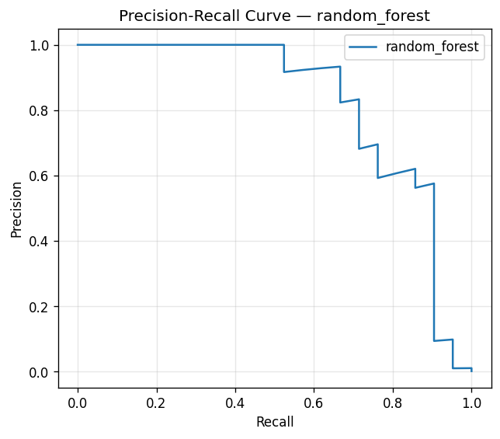
Fig 1. Precision-Recall curve — Random Forest (test set)
The curve's shape is informative on its own: precision holds near 1.0 until roughly 50–60% recall, then falls off as the threshold is lowered further to catch the harder, more disguised fraud cases — this is the trade-off the threshold-selection step is built to navigate deliberately rather than by accident.

5. Threshold Selection & Final Performance
Rather than defaulting to a 0.5 cutoff, a cost-based sweep was run assuming a missed fraud case costs roughly 100x more than a false alarm (reflecting typical chargeback and investigation costs versus the cost of a manual review). This produced an operating threshold of 0.41, giving:
 | Predicted: Genuine | Predicted: Fraud
Actual: Genuine | 12,465 | 14
Actual: Fraud | 2 | 19

- Precision: 57.6% — of the transactions flagged, just over half were genuinely fraudulent.
- Recall: 90.5% — the model caught 19 of the 21 fraud cases in the test set.
- False positive rate: negligible — only 14 genuine transactions out of 12,479 were flagged.
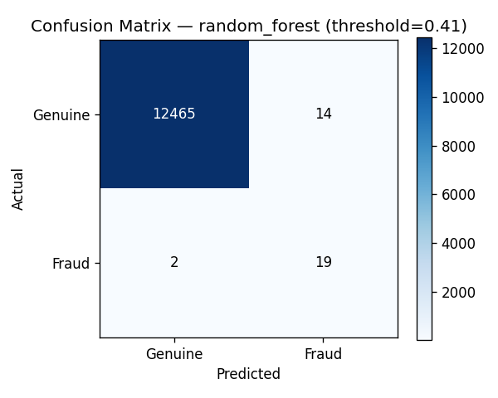
Fig 2. Confusion matrix at the selected operating threshold (0.41)
This threshold can be re-tuned at any time by adjusting the assumed cost ratio in the Threshold Selection section of the notebook — it is a business decision as much as a technical one, and should sit with whoever owns the fraud-review budget.

6. Risk Scoring Output
Rather than a binary flag, every transaction receives a 0–100 risk score and a band, so the review team can route work by severity instead of treating every alert identically:
Risk Band | Score Range | Transactions | Fraud Cases Caught
Low | 0 – 20 | 12,234 | 1
Medium | 20 – 50 | 248 | 5
High | 50 – 80 | 13 | 10
Critical | 80 – 100 | 5 | 5
Fraud cases concentrated heavily in the High and Critical bands (15 of 21), which is exactly the behaviour a usable risk system should exhibit — the riskiest-looking transactions genuinely are the ones worth reviewing first.

7. Business Value
- Reduces manual review load by concentrating attention on the small number of High/Critical transactions instead of the entire transaction stream.
- Makes the fraud/friction trade-off explicit and adjustable, instead of buried inside a fixed threshold nobody consciously chose.
- Produces an auditable, reproducible pipeline — every stage (cleaning, resampling, training, thresholding) is a separate, inspectable step.
- The prediction module can be plugged into a live transaction stream or a batch job with no changes beyond swapping the data source.

8. Limitations & Future Work
- The current dataset is a synthetically generated stand-in built to match real-world class imbalance and feature structure; results should be re-validated once real (or a licensed sample of real) transaction data is available.
- The cost ratio used for threshold selection (missed fraud vs. false alarm) is an estimate and should be replaced with actual figures from Risk/Finance.
- Fraud patterns drift over time; the model should be retrained periodically and monitored for degradation rather than treated as a one-time deliverable.
- Additional signals not present in this dataset — device fingerprinting, merchant category, geolocation mismatch — would likely improve recall further.

9. Conclusion
The system demonstrates that with the right combination of resampling, an imbalance-aware model, and a deliberately chosen threshold, it is possible to catch the large majority of fraud (90.5% recall) while keeping false alarms low enough to be practically actionable. The risk-scoring layer turns that model output into something a non-technical reviewer can use immediately, which was the core objective of the project.

